Task 3: Escape Sequences, Command History and Dynamic Memory Management
Objective
To apply escape sequences, store command history, navigate through previous and next commands, update the input buffer, test command recall functionality, dynamically allocate buffers, resize arrays, prevent buffer overflow, manage linked lists, release memory correctly, and verify memory management using Valgrind.
1. Command History and Input Buffer
The shell implements command history functionality to store previously entered commands. Escape sequences are used to detect special keys such as the Up and Down arrow keys. The Up arrow is used to navigate to previously entered commands, while the Down arrow is used to navigate forward through the command history.
The input buffer is updated whenever a command is recalled, allowing the user to edit or execute the recalled command.
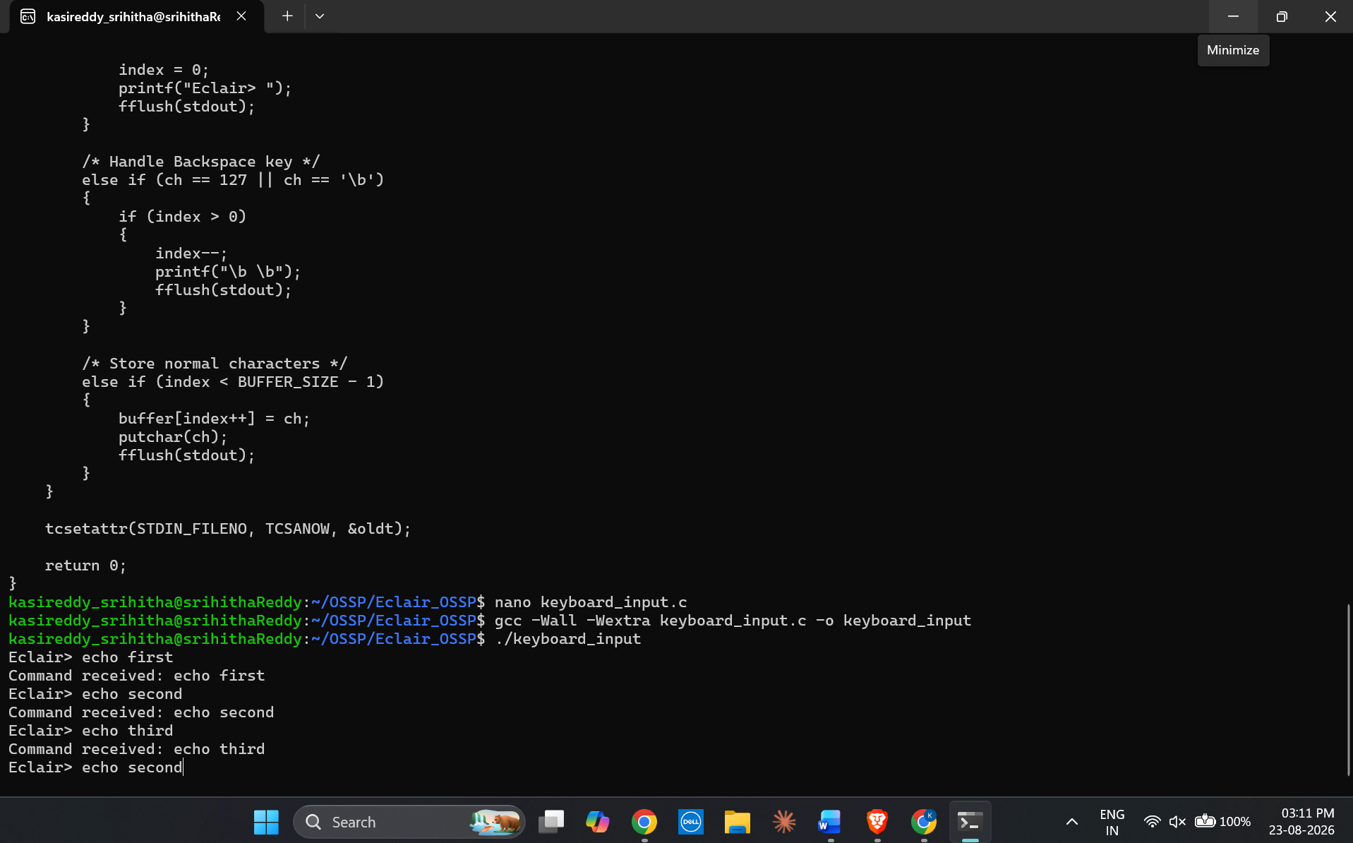2. Dynamic Buffer Allocation and Memory Management
Dynamic memory allocation is used to allocate buffers according to the required input size. Arrays are resized dynamically when additional space is required, which helps prevent buffer overflow.
Linked lists are used to manage dynamically allocated command history data. Memory allocated for buffers, arrays, and linked-list nodes is released properly after use to prevent memory leaks and invalid memory access.
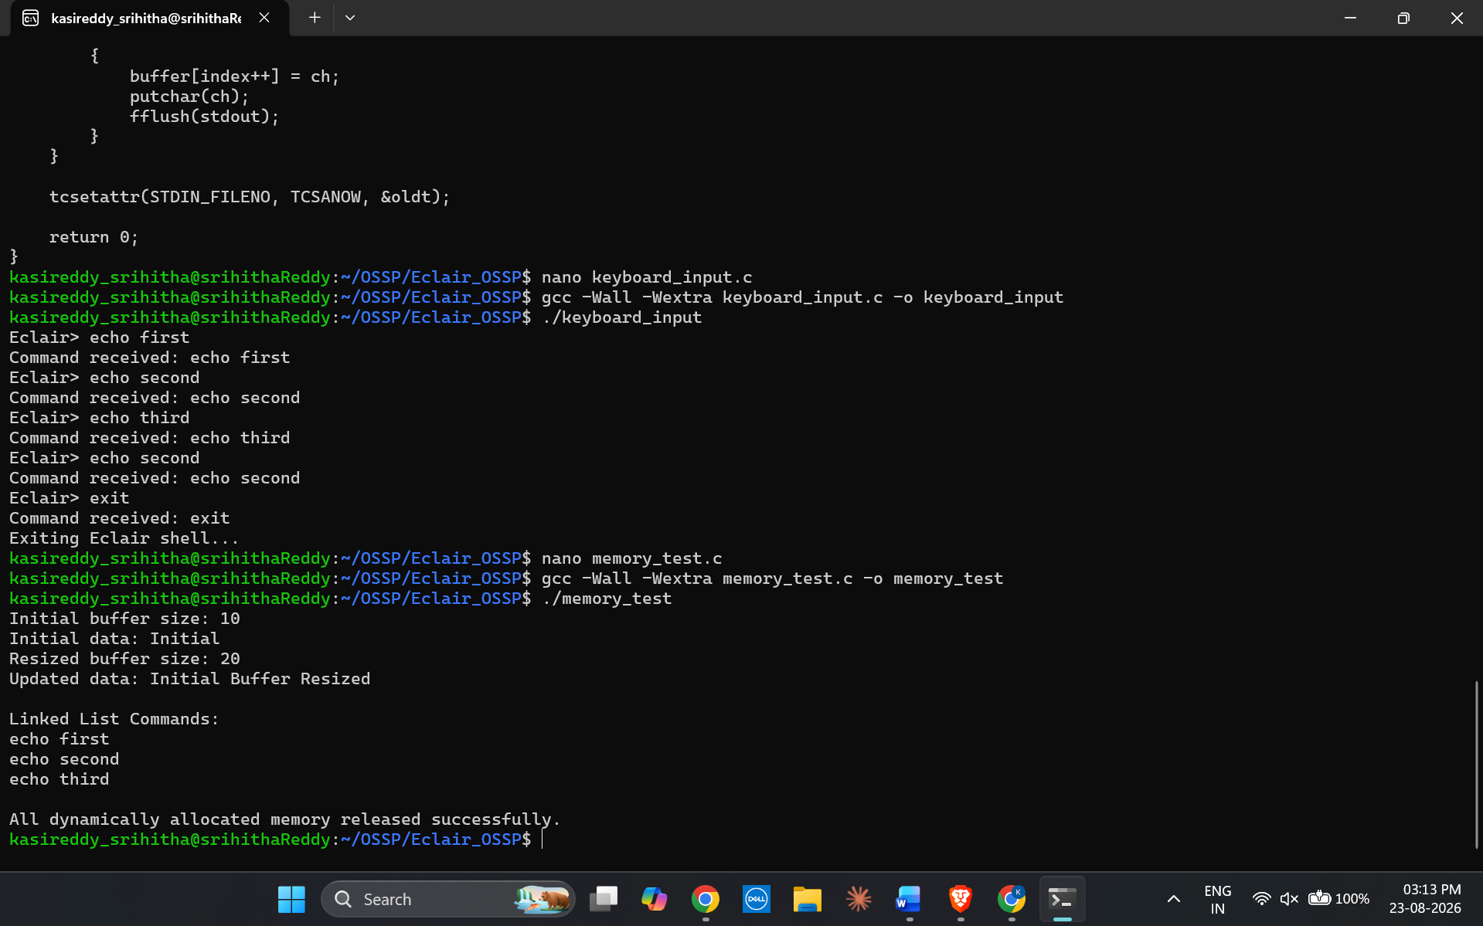3. Memory Verification Using Valgrind
Valgrind is used to verify the correctness of dynamic memory management. It checks the program for memory leaks, invalid memory accesses, and other memory-related errors.
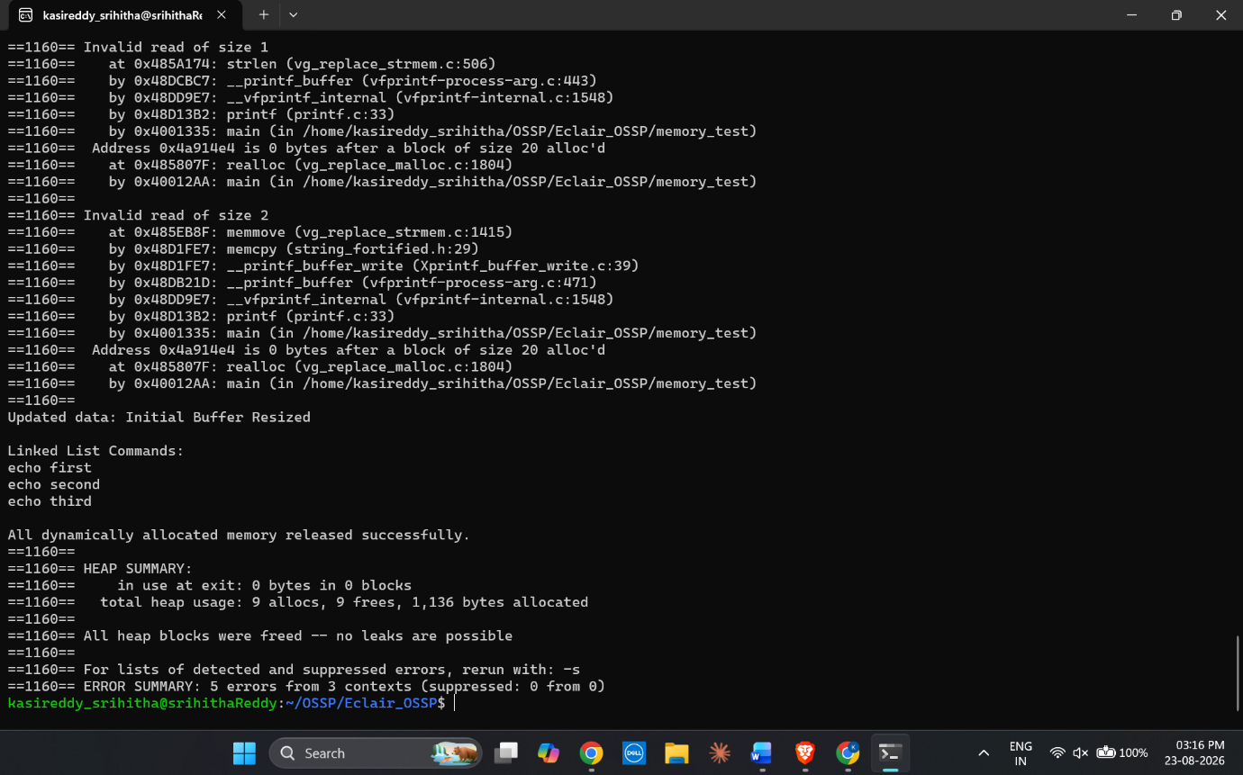Result
The shell successfully implements escape-sequence handling, command history navigation, input-buffer updates, dynamic buffer allocation, array resizing, and linked-list memory management. The allocated memory is released correctly, and Valgrind verification confirms that the program does not contain memory leaks or invalid memory-access errors.

